NAME: _____________ | Algebra
Quiz4-8 PRACTICE | DATE: Thursday, June 15, 2017

A graph of years and carbon dioxide in atmosphere (in parts per million) is below:
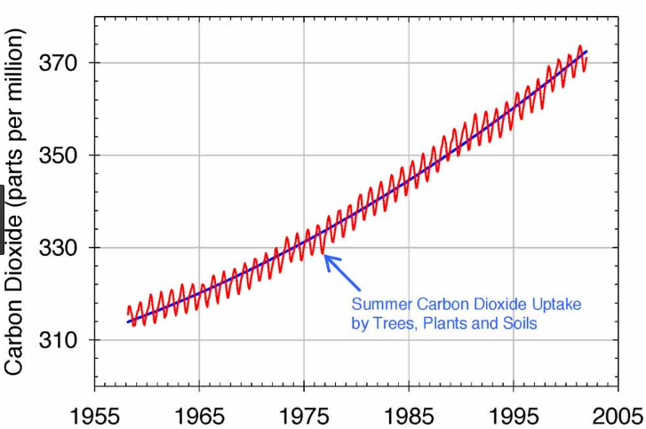
You draw a trendline and get the equation y= 1.25x + 255 where x is years since 1900.
What does the slope mean in real terms?

What does the y intercept mean?

Simulation:
- There are 10 students in this room. Im going to randomly call out students one at a time to play a game (Deal or no deal). On average, how many people will I need to pick until I call on you? Conduct a simulation with 20 trials. Write your results from your trials below.

Using your simulation:
- How many people on average did it take so that you are called?

- If we only play 3 times, what is chance you get to play?

- Sprite has a contest where 1 in 6 bottles wins. You are going to buy bottles until you win. How many bottles on average will it take to get a winner.
Conduct a simulation with 20 trials. Write your results from your trials below.

Using your simulation:
  - How many bottles on average will it take to get a winner?

  - What is the probability that you will only need to buy 2 bottles or less?

